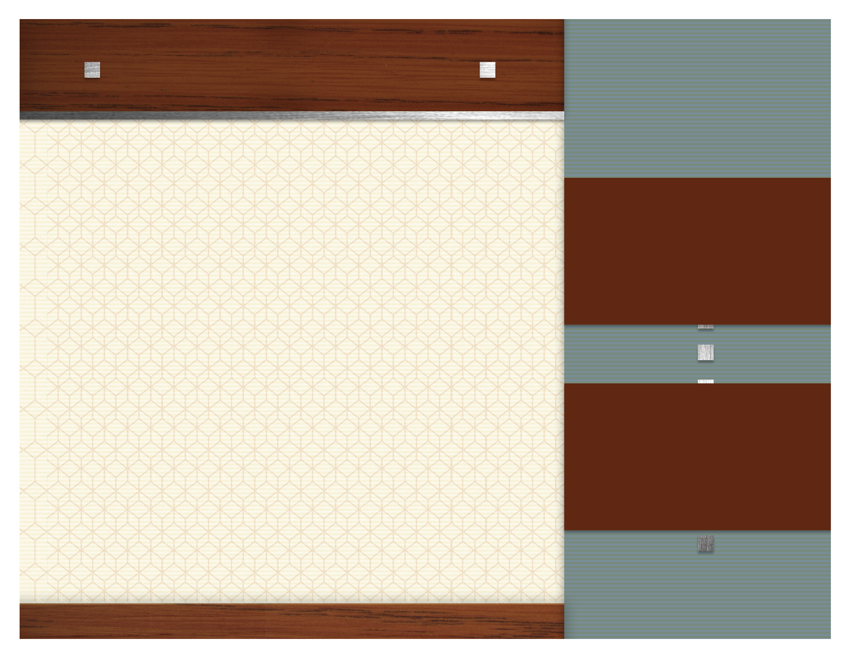
march Focus Items

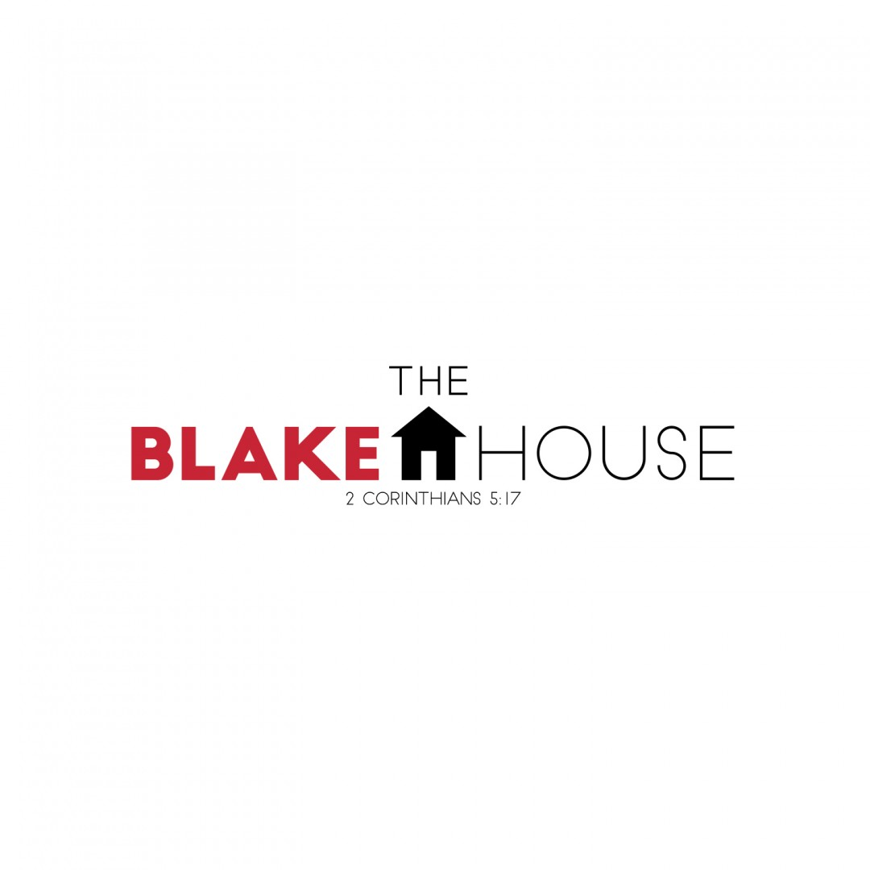

.

HCMS BACKPACK PROGRAM

See Sign-up Sheet
The Blake House

3/6

Toilet Paper

3/13

Coffee

3/20

Laundry Detergent

3/27

Mayonnaise



