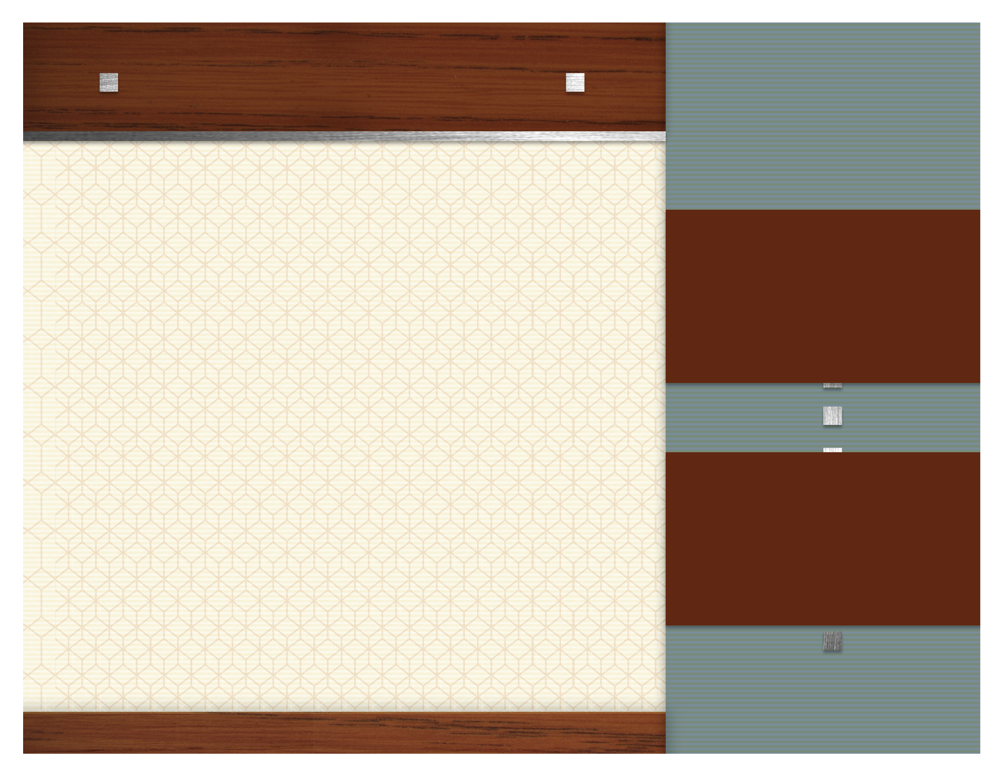
june Focus Items

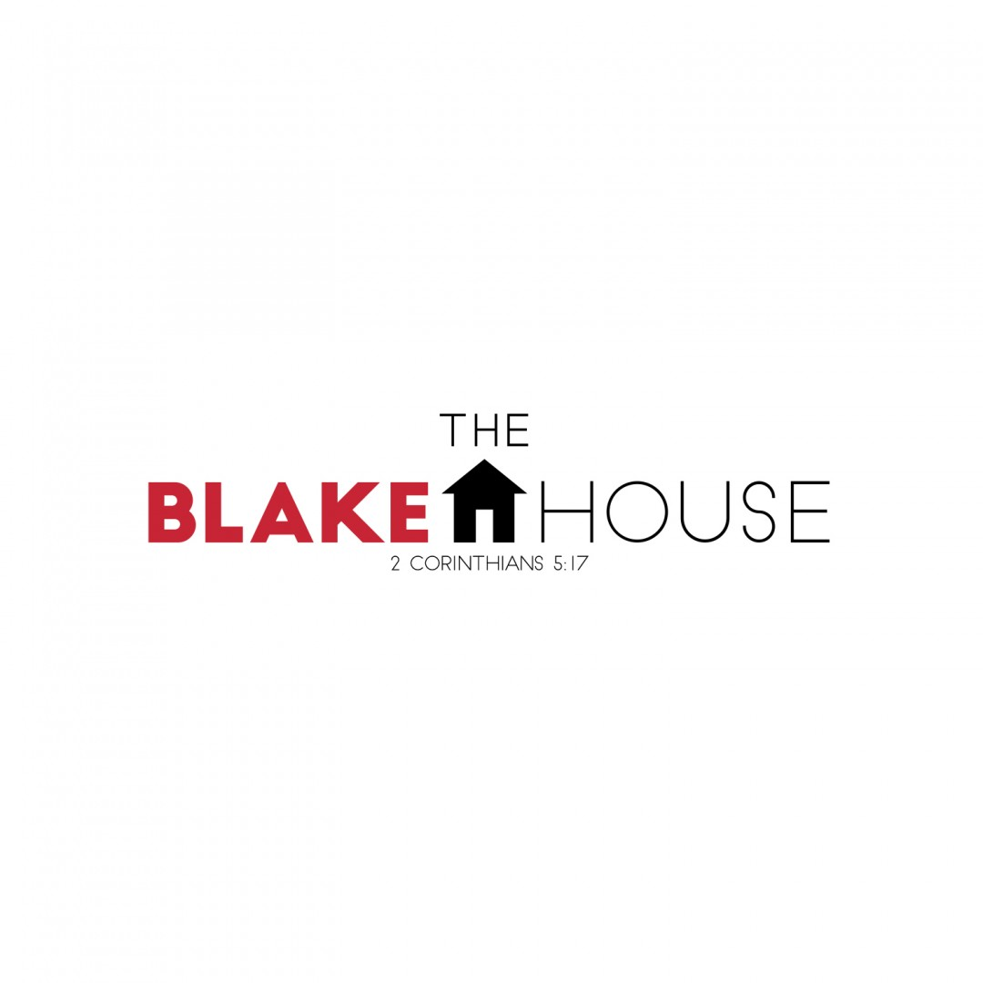

.

HCMS BACKPACK PROGRAM

Ramen Noodles
The Blake House

6/5

Toilet Paper

6/19

Coffee

6/26

Body Wash



