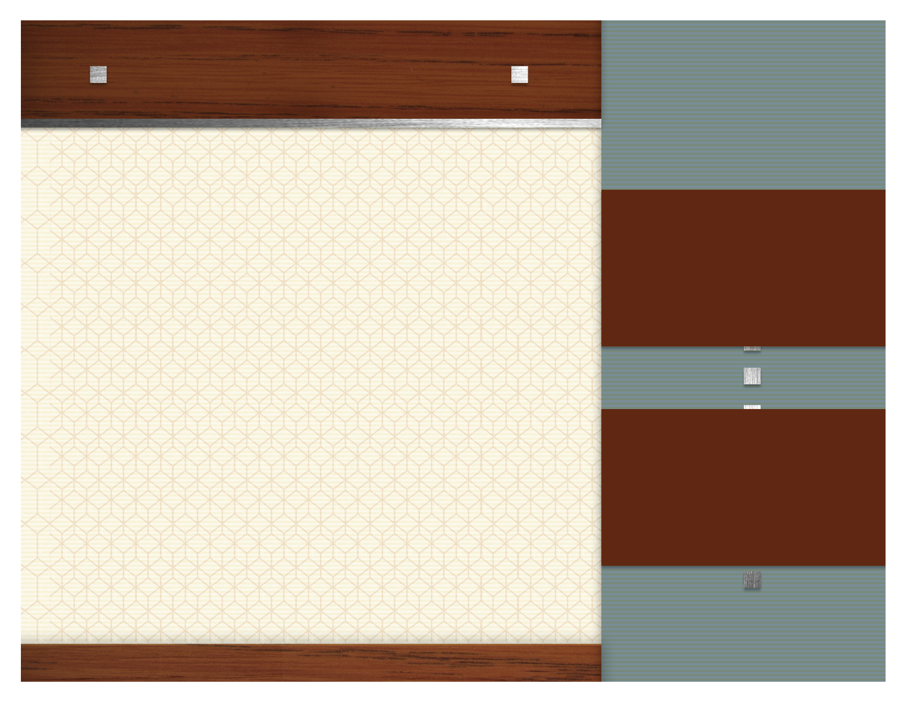
january Focus Items

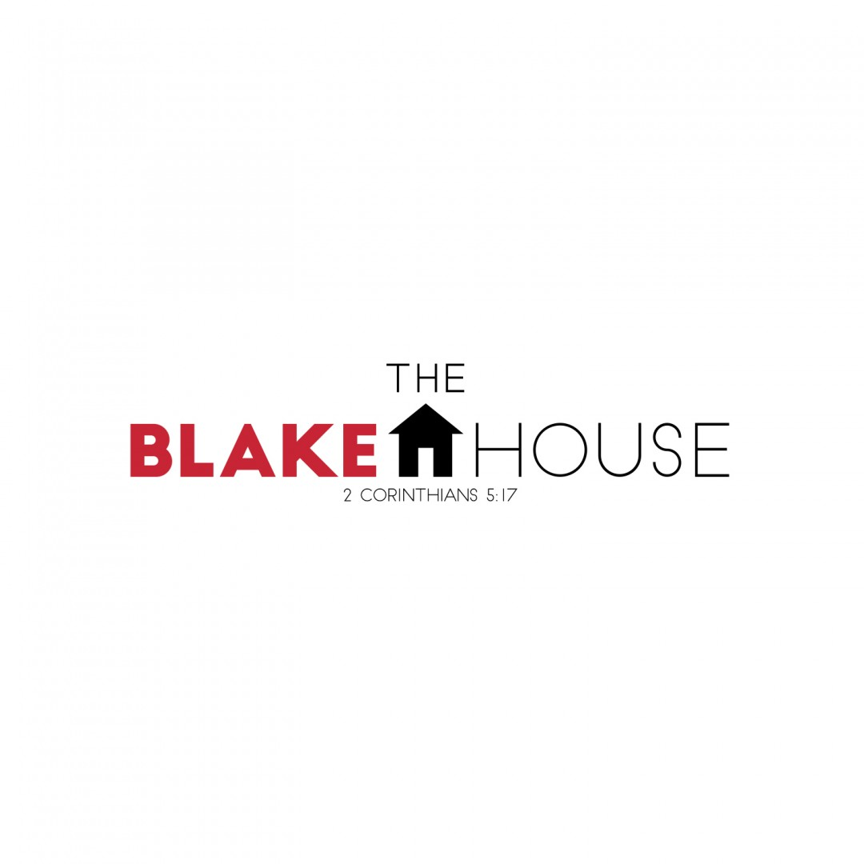

.

HCMS BACKPACK PROGRAM

See Sign-up Sheet
The Blake House

1/2

Toothpaste

1/9

Mayonnaise

1/16

Coffee

1/23

Dish Soap

1/30

Shampoo



